Modern Slavery
Statement
March 2021

Table of Contents

Section 1 – Introduction 3
Section 2 – About Jaybro Group 4
Section 3 – Operations and Supply Chain 5
Section 4 – Risks in our Operations and Supply Chain 7
Section 5 – Activities, Action and Outcomes 9
Section 6 – Remediation Approach 13
Section 7 – Asessing effectiveness 13
Section 8 – Consultation 13

Section 1 – Introduction

The Jaybro Group respects the fundamental human rights of all people and opposes modern slavery in all its forms as defined under the Modern Slavery Act 2018 (the Act). This includes serious exploitative practices such as human trafficking, slavery, servitude, forced labour, debt bondage, forced marriage and the worst forms of child labour. Modern slavery is a complex issue and all businesses are susceptible to modern slavery risks which can often be hidden in their business operations and supply chains. Jaybro Group recognises the importance of its role in the global collaborative effort to combat modern slavery and is committed to ensuring it has systems in place to actively identify, manage, and review effectiveness of actions taken against modern slavery risks to the business on an ongoing basis.

This statement was developed in accordance to the Act for the reporting entity Jaybro Group Pty Ltd (Jaybro Group) including Global Synthetics Pty Ltd, Jaybro NZ Ltd and Global Synthetics NZ Ltd which are entities under its control. The statement is a collective representation of the group as a whole, with regards to the risks of modern slavery and actions taken. The statement highlights the strategies and actions adopted to minimise the risk of modern slavery occurring in its operations and supply chain.

Our actions in FY20 consisted of the review and development of company policies, analysis of our supply chain and risks, and the commencement to incorporate modern slavery considerations in our supplier site audits in high risk areas. The COVID-19 pandemic hindered the progress our planned activities. Management commits to refocusing its effort for this cause during FY21.

Our intention for the following financial year is to deepen our understanding of our supply chain risks and increasing transparency in the lower tiers of our supply chains where the risks are higher and less visible. We commit to enhanced due diligence in our supply chain including self-assessment surveys, supplier contract clauses and site audits as well as working together with key suppliers to explore what collaborative actions can have the greatest impact to reduce the risk of facilitating modern slavery practices. Jaybro Group recognises there is no simple solution to eliminate the risks of modern slavery from its business and will require a process of refinement in its approach over the coming years to strengthen its response against modern slavery.

Section 2 – About Jaybro Group

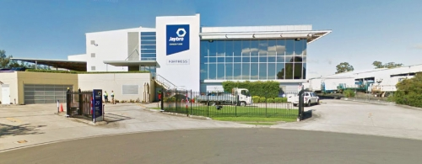
Jaybro Group Pty Ltd ACN 159 122 488 has its registered office at 29 Penelope Crescent, Arndell Park, New South Wales. It is a full-service supplier of consumables, safety products, geosynthetics, temporary fencing and safety barriers to the Australian and New Zealand civil and construction sector. Servicing the local industry for over 25 years, Jaybro Group has a total of 270 employees across all its locations and generates $220 million in sales annually.
With offices and warehouses across Australia and New Zealand, Jaybro Group strives to provide its customers with industry-leading service, fast delivery, expert advice and quality products. Since its inception, the business has experienced strong organic growth underpinned by its commitment to ‘wow customers with service’. In addition to this growth, Jaybro has flourished through strategic acquisitions that complement the core business model.
In 2012 Jaybro acquired the first of many companies which now make up the Jaybro Group. 2017 saw Champ Private Equity invest in Jaybro Group, spring boarding the business into the next stage of growth. The group owns several brands in its portfolio including Fortress, Defender Safety, Coverlite, Squid and Brandwrap, each of which have been selected to enable Jaybro Group to offer superior service to its core customer base. A trusted supplier to some of Australia’s biggest infrastructure companies, Jaybro is now firmly entrenched as one of the leading names in civil consumables.

Section 3 – Operations and Supply Chain
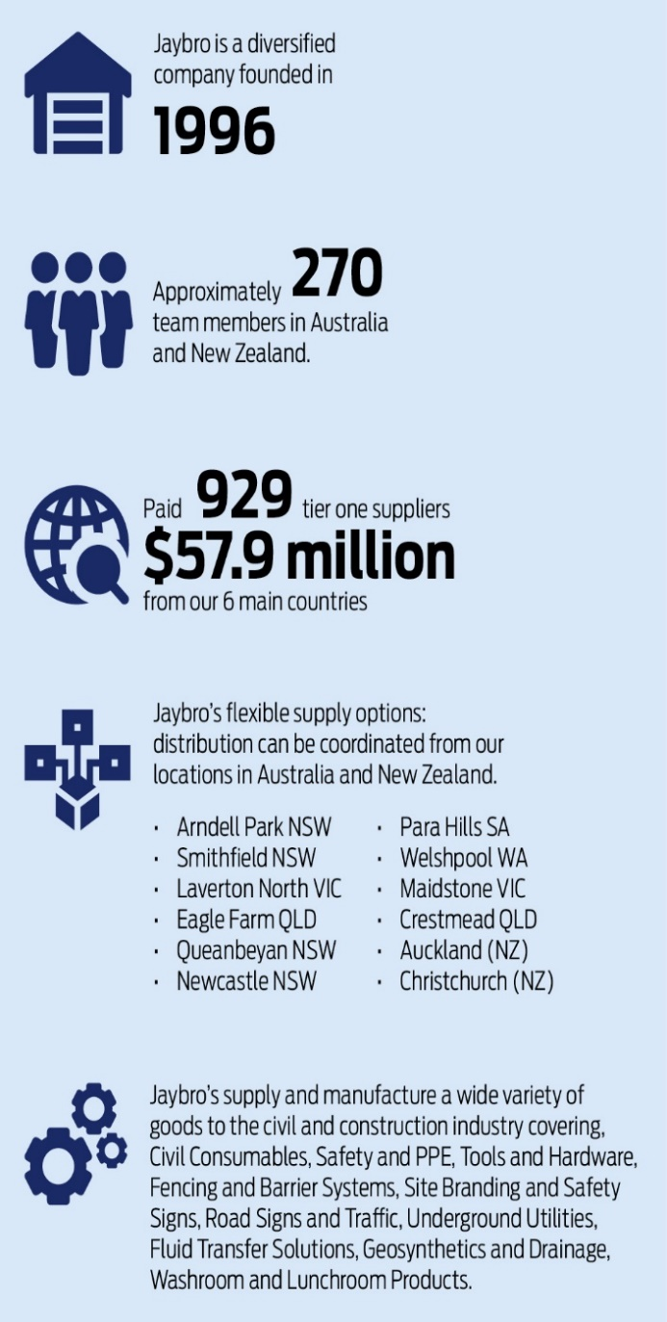

Jaybro Group Operations

As a predominantly sales and distribution organisation, Jaybro Group has 12 distribution sites across Australia and New Zealand, with sales and other operational functions supported from head office. The manufacturing operation consists of custom banner mesh printing, precast concrete barriers, and printed road and safety signs from our facility in Sydney.

Our workforce comprises warehouse personnel, manufacturing operators, sales reps and head office team members in roles such as finance, IT, marketing, customer service, procurement, logistics and other general administrators.

Jaybro Group Supply Chain

As well as procurement of a limited range of products to support our general operations, we source the majority of our resale range directly from reputable manufacturers of high quality products from around the world including leading brands such as Deltabloc, GEOmasta, Win United, 3M, UVEX, Steel Blue, Oliver, MSA, and DNC Workwear.

Our supply chain team focuses on building long term sustainable partnerships with suppliers and seeking innovative opportunities to ensure reliability and excellence in both product and delivery of service to the customer.

The 6 main countries from which we procure the bulk of our goods are China, India, Malaysia, Vietnam, USA and Australia as shown below. All goods for resale or are sourced directly from manufacturers of the finished goods while goods not for resale are mostly sourced through vendors. We engage local freight and transport providers to coordinate our road, air and ocean freight.
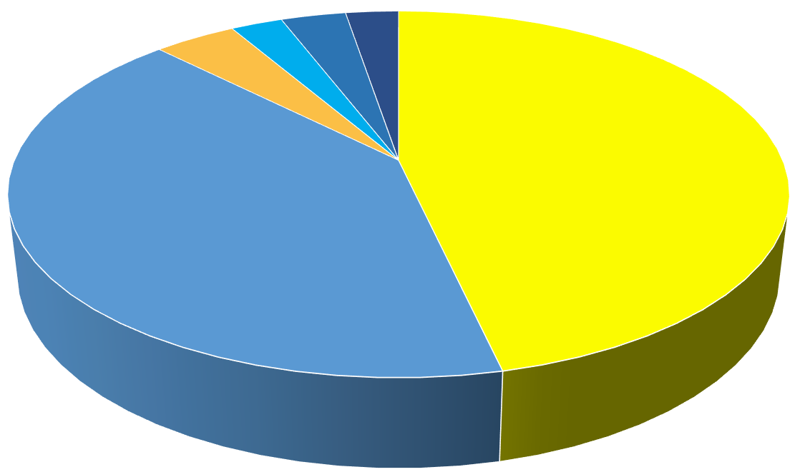
Australia
Goods not for resale
- Staff Uniforms
- IT/Computers
- Warehouse/Office Fitout
Services
- Freight/Shipping
Intermediate Goods
- Manufacturing Consumables

China
Goods for resale
- Geosynthetics
- Tools and Hardware
- Cleaning Chemicals
- Construction Consumables
- Traffic Signage
Intermediate Goods
- Textile Banners
Vietnam
Goods for resale
- Construction Consumables
Malaysia
Goods for resale
- Construction Consumables
USA
Goods for resale
- Safety Barriers
India
Goods for resale
- Geosynthetics
- Clothing/Workwear
Goods not for resale
- Staff Uniforms

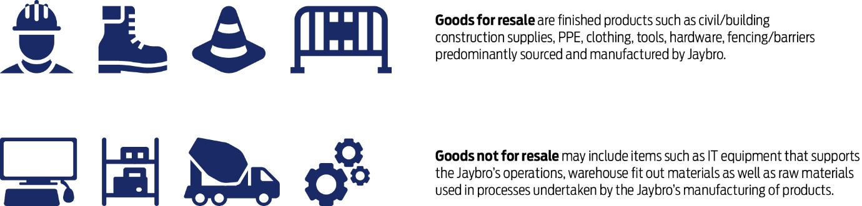

Section 4 – Risks in our Operations and Supply Chain

Risks in Jaybro Group Operations

We consider that the risk of modern slavery in our operations to be low. Our HR policy requires right to work credentials to be checked and all prospective employees undergo police checks to ensure minimum age requirements are met. Workers’ rights are protected by workplace legislation, and individual employment contracts are written in compliance with legislation or covered by relevant awards.
All employees undergo a comprehensive induction program covering policies such as code of conduct, and anti-discrimination and harassment ensuring they understand their own rights as well as their obligation to respect the rights of fellow employees across the business. In due course, a modern slavery training module will be added to employee inductions to further increase awareness of modern slavery risks and how to identify red flags.
Open communication is actively promoted within the organisation with direct access to the CEO highlighted to all employees who may have concerns, grievances or any other issues to raise. Particularly in light of COVID-19, the company has taken additional steps to facilitate flexible working arrangements and established programs for the care of employee health and well-being.

Risks in Jaybro Group Supply Chain

As with many other companies operating in our sector, the risk of modern slavery is heightened in our supply chain particularly beyond tier 1 suppliers as transparency of conduct and transparency of risks gradually diminishes. Jaybro Group looked at the potential risks in the supply chain by comparison against commonly published modern slavery risks according to sector or industry type, geographic or demographic risks, vulnerable populations and entity or business structure types where applicable.
The following areas have been identified as having the highest risk of modern slavery impacts in our supply chain, particularly in tier 2 and beyond:
- Unknown origin of raw materials or intermediate components used in the manufacture of finished goods purchased such as in IT hardware, and clothing/textiles.
- Outsourcing of certain manufacturing by suppliers to countries with higher modern slavery risks.
- Manufactured goods from high risk countries such as China, Vietnam and India particularly where lower tier suppliers are not visible.

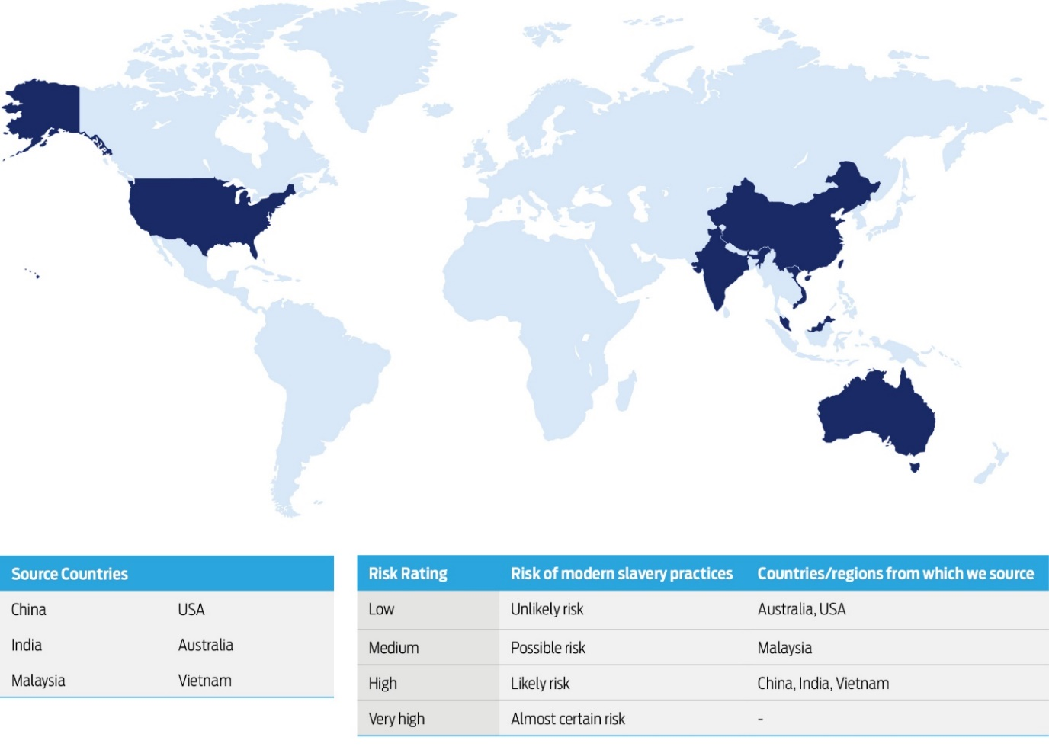
Impact of Covid-19 pandemic

The Covid-19 pandemic has had worldwide impacts across all economies causing an increase of modern slavery risk in key sourcing countries particularly relating to worker health and safety. Our own business experienced disrupted business and shipping activity, lockdown/travel restrictions, and potential impacts on the health and well-being of our employees. During this time Jaybro Group committed to maintaining good procurement practices and open communication with suppliers to encourage stability for our supplier operations.

Due to strained resources as a result of the pandemic and hindered ability to undertake certain activities from both the business and supplier perspectives, activities in the following financial year are expected to provide greater impact to assess and address the risk of modern slavery in the business.

Section 5 – Activities, Actions and Outcomes

GOVERNANCE

The responsibility for human rights matters, including modern slavery, operates within the company's overall governance framework. All levels of management have a responsibility to consider the risks of modern slavery in their areas of management.
The Jaybro Group board has overall responsibility for the oversight and approval of all company policies which includes the Modern Slavery Policy.
Jaybro Group is in the process of formalising a Modern Slavery Steering Committee to be chaired by the Group Supply Chain Manager. The Committee will include senior members from different divisions across the company including procurement, legal, and human resources to ensure coverage of relevant issues relating to modern slavery from various perspectives.
The role of the Committee will be to monitor and coordinate Jaybro’s overall response to modern slavery risks in compliance with the Act.
In FY2021, we will develop a modern slavery framework that seeks to formalise our approach to identifying, assessing, and addressing modern slavery risk. This will be reviewed annually and refined as we continue to develop our approach.

SUPPLIER DUE DILIGENCE

Suppliers are fundamental to the Jaybro Group business. Jaybro Group dedicates many resources to choose the right supply partners to ensure alignment of values, expectations, and performance. Our standard procurement procedure requires all suppliers to agree to comply with our Supplier Code of Conduct and related policies as part of the supply agreement. Specific clauses relating to modern slavery will be added in FY21.

The suitability of suppliers is determined across a number of key factors. In the screening process, geographical considerations, size of business, reputation in the category or goods or services, supply capability, financial stability, cost of goods or services, ethical sourcing policy and value alignment are all taken into account and applies to all new prospective suppliers.

Based upon the initial screening, the procurement team determines the level of assessment required to validate the supplier’s ability to meet required standards. Where deemed necessary, supplier site audits are arranged and conducted by either a Jaybro employee or third-party representative. In FY21, Jaybro Group will issue a supplier pre-qualification questionnaire including assessment of modern slavery risks.

Jaybro’s supplier due diligence also evaluates:
- evidence of financial crime or fraud
- workplace safety
- insurance and licensing
- compliance with our Supplier Code of Conduct

In due course, modern slavery and associated key risks will formally and specifically form part of the supplier due diligence process.

In FY2021, we will conduct a detailed assessment of our suppliers that have been assessed as having a high risk of modern slavery practices in our initial screening. It is expected that verification procedures and due diligence processes will be further developed based on new risks and challenges encountered in undertaking these new activities.

The Jaybro Group has taken a phased approach, prioritising analysis on the tier 1 supplier level to identify the highest risks. In FY21 Jaybro will continue to build opportunities to engage and leverage relationships with, suppliers, and business partners to enhance recognition of human rights across their activities, alongside other sustainability issues. We recognise there are limitations to our ability to influence our indirect suppliers but that we have a responsibility to work constructively with our direct suppliers to build capacity both within their organisations and their own supply chains.

PROCUREMENT MANAGEMENT

The Jaybro Group procurement team is led by the Group Supply Chain Manager and supported by sourcing and purchasing professionals. The Procurement team manages suppliers in key spend categories and takes a risk-based approach in assessing and monitoring all suppliers.

The types of supply arrangements can vary depending on the nature of the good or service provided. This ranges from formal procurement agreements for long- and short-term supply contracts to less formal arrangements such as purchase order terms and conditions.

POLICIES AND STANDARDS

Jaybro Group’s core values requires respect and the collective respect of fundamental human rights.

The Jaybro Group Modern Slavery Policy was developed in FY20. The raising of awareness at management level was also initiated to assist in the collective development of the group’s approach to manage risks associated with modern slavery in line with the Jaybro Group’s broader approach to respecting human rights.
In FY2021, we will update and implement our Supplier Code of Conduct and Procurement Policy in line with our commitment to human rights and addressing modern slavery.

The Jaybro Group board and senior executive management teams take breaches of our codes and policies very seriously. We have consistent and transparent practices in place to address any non-compliance with our codes and policies.

The following table provides a general overview and outlook of our current and intended future approach.
 |  | FY20 | FY21 | Ongoing | Future Planned Activities
Governance | Development of Modern Slavery Policy
 | Review and update related policies: Supplier Code of Conduct, Procurement Policy, Whistleblower Policy.
 | Assign team responsible for overseeing the risk management program against Modern Slavery.
 | Incorporate modern slavery risks into internal audit program.
 | Annual reports to Board.
 | Development of risk mitigation strategies to minimize risk to the overall business based on susceptibility to risk factors.
Risk Identification and Due Diligence | Raise awareness on issues surrounding modern slavery and its risk factors to all levels of the business.
 | Supply chain mapping of Tier 1 suppliers and identification of key risks.
 | Identify Tier 2 and below suppliers based on risks assessed.
 | Provide further training on specific employee roles and responsibilities with respect to modern slavery policy and associated processes.
 | Expand due diligence for new suppliers to determine risk level and control measures.
 | Implement acknowledgement process for Supplier Code of Conduct for all suppliers.
 | Minimum standards for ethical sourcing issued to new suppliers as part of compliance program.
 | Add modern slavery clauses for all new supplier contracts.
 | Survey issued to all tier 1 suppliers to assist prioritisation of risks.
 | Follow up survey to Tier 1 suppliers.
 | Expand survey to Tier 2 and below based on risks identified.
 | Expand existing supplier site audit program to cover risk factors and red flags for modern slavery.
Risk Management and Reporting | Develop and implement reporting system for identified cases and/or extreme risk factors or concerns in the supply chain.
 | Ensure awareness, accessibility and assurance of confidentiality for reporting mechanism is communicated to suppliers.
 | Develop risk analysis procedure for reported incidences.
Remediation | Work with suppliers to remediate any reported incidences
Review of Effectiveness | Develop and implement procedure to review effectiveness of risk management activities.
 | Annual review of effectiveness of actions with respect to risk minimization.
 | Develop measurable outcomes or KPI targets to aid review activities.
Improvements | Examine other entity’s approaches to aid continuous improvement activities.
 | Collaborate with suppliers to help identify where the greatest impacts can be made.
 | Develop improvements to system raised from reviews of effectiveness.

Section 6 – Remediation Approach

During the FY20 period remediation activities were not required as no actual incidences or practices of modern slavery were identified.

In the event that our business is found to have caused or contributed to an actual instance of modern slavery, our immediate priority be the safety and wellbeing of the victim and then to work with the supplier(s) in question to facilitate change of practices to minimise the risk of future recurrence. It is generally acknowledged that disengaging from the supplier may not combat the problem of modern slavery and in fact could have further negative consequences for victims. Therefore, specific remediation activities will be determined on a case-by-case basis to ensure the most appropriate and effective actions are undertaken.

The Whistleblower Policy is publicly available on the Jaybro website to encourage reporting of concerns both internally and externally to the business without fear of adverse consequences for the reporting individual.

Section 7 – Assessing Effectiveness

We will be tracking the effectiveness of our actions by reference to the table of our future approach as outlined in Section 5. Our aim is to improve our ability to assess and address modern slavery risks in our operations and supply chains year on year.

It is expected that the way we assess effectiveness will develop over time particularly as we embed and develop human rights considerations in the way we conduct our business.

Section 8 – Consultation & Approval

This Statement has been prepared in consultation with our key teams including Commercial Strategy Planning, Procurement, Legal, Risk, Ethics and Compliance, and Internal Audit and Advisory teams. This collaboration included the senior executive team representing the reporting entity and the entities under its control.

This Statement was approved by the Board of Jaybro Group Pty Ltd on [date].
Signed,
[signature]

Name
[Title of responsible member signing off]
[Date]

